DATALEMUR ==== it covers everything

Types of commands in SQL:
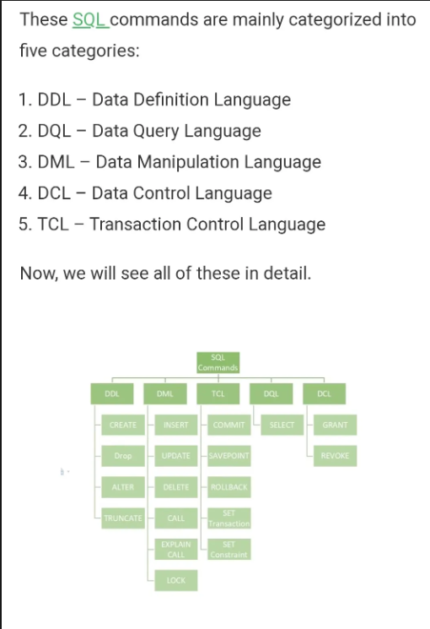

the DROP command is used to remove the whole database or table indexes, data, and more. Whereas the TRUNCATE command is used to remove all the rows from the table.

1st where 2nd group by 3rd printing columns 4th order by

SQL:
Left outer join -
For each left row checks whether there is a match with any right row. If match then left and right row combinely returned. If no match then left row along with NULL values on right row returned. In general no. of rows in result equal to no. of rows in left table
If right table contain duplicate rows, then no. of rows in result table will be greater than no. of rows in left table. i.e it should pair with each matched duplicate right row
Inner join - left outer join ^ right outer join
Full outer join -
left outer join (union) right outer join
In below first four are weapons of the SQL
SQL - group by, order by
Creating intermediate table
Joins(cartesian product)
PARTITION BY()
NESTED queries - needs IN, NOT IN, ANY, ALL, EXISTS, NOT EXISTS
Union, intersection, minus/except
Do supercloud master medium question in Datalemur(smart one)
IBM db2 product analysis

Group by column1, column 2 = grouping with 2 columns
= NULL wont exists we have to write is NULL
<> not equal to
= equal to (don’t use ==)
|| for concatenation Eg: ('$' || ROUND(SUM(total_sales) / 1000000) || ' million')
In leftjoin questions, rather than left join try to do individually
Eg: select (select count(*) from table2)/(count(*))
from table

% = represents 0 or more characters
_ = represents a single character
Above are some of the wildcards and they are used along with like
Ex; select student_id from students where email LIKE “%.com” -> emails that ends with .com
select student_id from students where name LIKE “h%” -> names that starts with h
Also once refer CASE END:
CASE
WHEN condition1 THEN result1
WHEN condition2 THEN result2
WHEN conditionN THEN resultN
ELSE result
END;
SELECT OrderID, Quantity,
CASE
WHEN Quantity > 30 THEN 'The quantity is greater than 30'
WHEN Quantity = 30 THEN 'The quantity is 30'
ELSE 'The quantity is under 30'
END AS QuantityText
FROM OrderDetails;

Writing LIMIT 3 at last of the query = return top 3 rows
ROUND(something, 2) = roundoff up to 2 decimal places

Timestamp is in form = YYYY-MM-DD HH:MI:SS
Lets say x = YYYY-MM-DD HH:MI:SS
EXTRACT(YEAR FROM x) = YYYY
EXTRACT(MONTH FROM x) = MM (without leading zeros)
EXTRACT(DAY FROM x) = DD (without leading zeros)

Casting timestamp into date:
CAST(x AS DATE)

1.ROW_NUMBER():
Each row gets a unique number, even if two rows have identical values in the ORDER BY clause.
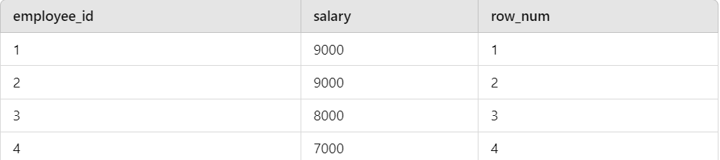

2. RANK():
Rows with the same values in the ORDER BY clause receive the same rank, but subsequent ranks will skip numbers (i.e., there will be gaps).
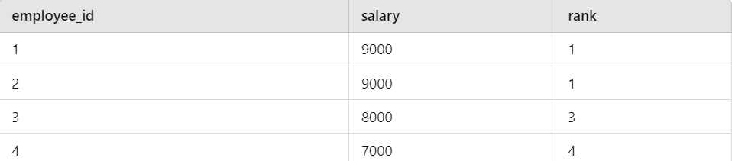

3. DENSE_RANK(): remember employee salaries
Similar to RANK(), but without gaps in the ranks.
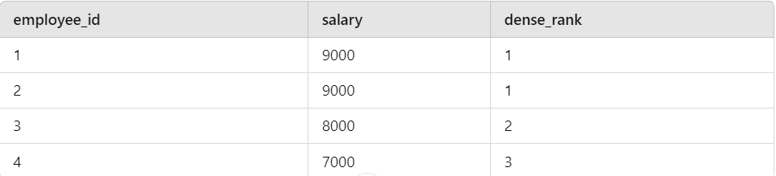

Partition by:
Window_function ( expression )
Over ( partition by expr [order_clause] [frame_clause] )

Types of window functions:
Ranking Functions:
- ROW_NUMBER()
- RANK()
- DENSE_RANK()
- NTILE(n)
Aggregate Functions:
- SUM()
- AVG()
- COUNT()
- MAX()
- MIN()
Value Functions:
- LEAD()
- LAG()
- FIRST_VALUE()
- LAST_VALUE()
Cumulative/Running Total Functions:
- CUME_DIST()
- PERCENT_RANK()

Return type of SUM( ) depends on datatype of the column

select c1, c2 from t1
UNION
select c1, c2 from t2

select c1, c2 from t1
UNION ALL
select c1, c2 from t2

select c1, c2 from t1
INTERSECT
select c1, c2 from t2

select c1, c2 from t1
MINUS/EXCEPT
select c1, c2 from t2

Union - no duplicates
Union all - with duplicates
Both INTERSECT and MINUS
- removes duplicates

column name(name, rollno)

select count(*) from students;
select count(names) from students

count(names) = no of non NULL names in the group
count(DISTINCT names) = no of non NULL distinct names in the group
count(*) = no of non NULL rows in the grp(at least one non NULL value in a row then it counts)

select count(*), names from students group by names;
select count(names), names from students group by names;
select count(rollno), names from students group by names;

select avg(rollno), names from students group by names;

select count(*) from
(select count(*), names from students group by names) as newtable;

Get the names of students who obtained the maximum marks in the branch of EC
Select name, max(marks)
from gateMarks
where branch = ‘EC’

Will not work
Only aggregate functions can be specified here. It does not make sense to include normal attributes ! (unless they are
grouping attributes – to be seen later)

Select regNo, name, marks
from gateMarks
where branch = ‘EC’ and marks =
(select max(marks)
from gateMarks
where branch = ‘EC’)

CREATE TABLE new_table_name AS
SELECT column1, column2,...
FROM existing_table_name
WHERE ....;

SELECT column_name(s)
FROM table_name
WHERE column_name operator ANY
(SELECT column_name
FROM table_name
WHERE condition);

SELECT column_name(s)
FROM table_name
WHERE column_name operator ALL
(SELECT column_name
FROM table_name
WHERE condition);

Operator: = > < >= <=

SELECT TOP 50 PERCENT column_name(s) FROM table_nams;

SELECT column_name(s)
FROM table_name
WHERE EXISTS
(SELECT column_name FROM table_name WHERE condition);

Similarly for NOT EXISTS

Obtain the department Id and name of
departments that do not offer any 4 credit courses.
select d.deptId, d.name
from department d
where NOT EXISTS ( select courseId
from course c
where c.deptNo = d.deptId and
c.credits = ‘4’ )

Obtain the department Id and name of departments
whose courses are all 3-credit courses.
Equivalently, obtain the department Id and name of departments
that do not offer a single course that is not 3-credit course
select d.deptNo, d.name
from department d
where NOT EXISTS ( select c.courseId
from course c
where c.deptNo = d.deptId and
c.credits ≠ 3);

SELECT num1 + num2 + num3 - GREATEST(num1, num2, num3) AS sum_except_max
FROM your_table;

SELECT MAX(salary) AS SecondHighestSalary
FROM your_table
WHERE salary < (SELECT MAX(salary) FROM your_table);

Find the numbers which consecutively occurs 3 times
column name(Id, numbers)

SELECT DISTINCT a.numbers
FROM your_table_name a
JOIN your_table_name b ON a.Id = b.Id+1
JOIN your_table_name c ON a.Id = c.Id+2
WHERE a.numbers = b.numbers
AND a.numbers = c.numbers;

Select a.numbers from
table_name a where a.numbers =
(select b.numbers from
table_name b where b.numbers =
(Select c.numbers from
table_name c where
a.date = b.date + 1 and
b.date = c.date + 1))

Write an SQL query to find the days when temperature is greater than previous days

SELECT date
FROM temperature_data t1
WHERE temperature > (
SELECT MAX(temperature)
FROM temperature_data t2
WHERE t2.date < t1.date
);

Select t1.date from
temperature_data t1
join temperature_data t2
on t1.date>t2.date
group by t1.date having t1.date>max(t2.date)

Write an SQL query to delete duplicate rows.
Column name(Id, num)

Delete from table_name where id IN
(select Id from table_name group by num having count(num)>1).

//NOT IN is also defined in sql

Special focus:
IBM db2 product analysis
App Click-through Rate (CTR) [Facebook SQL Interview Question]

